**Questions**

Question 1 Use the final_assignments table, test event table and orders table to calculate the order binary for the 30 day window after the test assignment for item_test_2 (You may include the day the test started)

Question 2 Use the final_assignments table, test even table and orders table to calculate the view binary, and average views for the 30 day window after the test assignment for item_test_2. (You may include the day the test started)

Question 3 compute the lifts in metrics and the p-values for the binary metrics ( 30 day order binary and 30 day view binary) using a interval 95% confidence.

**SQL STATEMENT AND EXPLANATION**

**Question 1.** Calculating the order binary, and average views for the 30 day window after the test assignment for item_test_2

SELECT

test_assignment,

SUM(order_binary) AS orders_completed_30d,

COUNT(DISTINCT item_id) AS items,

SUM(orders)/COUNT(item_id) AS average_views_per_item

FROM

(SELECT

test_events.item_id,

test_events.test_assignment,

test_events.order_date,

test_events.test_number,

test_events.test_date,

COUNT(invoice_id) AS orders,

MAX(CASE WHEN (order_date > test_events.test_date AND DATE_PART('day', order_date - test_date) <= 30)

THEN 1 ELSE 0 END) AS order_binary

FROM

(SELECT

A.item_id AS item_id,

test_assignment,

test_number,

test_start_date AS test_date,

created_at AS order_date,

invoice_id

FROM

dsv1069.final_assignments AS A

LEFT JOIN

dsv1069.orders AS O

ON

A.item_id = O.item_id

WHERE

test_number = 'item_test_2'

) AS test_events

GROUP BY

test_events.item_id,

test_events.test_assignment,

test_events.order_date,

test_events.test_number,

test_events.test_date

) AS order_binary

GROUP BY test_assignment

**EXPLANATION**

***Step 1***

I created a temporary table called "test_events" using a sub query. I then used a LEFT OUTER JOIN to merge information from two tables, final_assignments (aliased as "A") and orders (aliased as "O") and it only returns rows where test_number = 'item_test_2' and , certain columns are retrieved as seen in the query from the table

***Step 2***

I calculated the aggregates from the step 1 main query. I then used the subquery 'order_binary' to calculate several aggregated metrics for each 'test_assignment'.

I used the MAX and CASE statements to help determine whether a condition is met and return either 1 or 0. The number of days that separate order_date and test_date for the 30 days is determined by the formula DATE_PART('day', order_date - test_date). The DATE_PART function is used to separate the day portion of the time span.

This same procedure is used to handle Question 2 for the view_binary test.

**Question 3**

**I used Abba for interpreting the results of binomial experiment/test.**

**Results:**

**● Order binary**

After doing the tests from the aforementioned SQL statement, I discovered that insufficient samples had been gathered to be able to identify a statistically significant lift of 1%. The true mean is probably between -10% and 12%, according to the p-value of 0.86 that was discovered. This outcome lacks statistical significance. Between the two treatments, there is no discernible difference in the number of orders placed within 30 days of the designated treatment date. 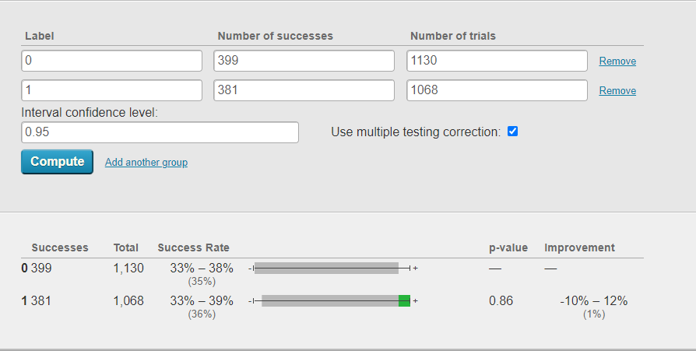

|  |  |  |  |  |
| --- | --- | --- | --- | --- |
| index | test_assignment | orders_completed_30d | items | average_views_per_item |
| 0 | 0.0 | 399 | 1130 | 1.004173 |
| 1 | 1.0 | 381 | 1068 | 1.004659 |

* **View Binary**

My findings and interpretations for the view binary indicated that insufficient samples had been gathered to be able to identify a statistically significant lift of 2.6%. The true mean is most likely to range from -1.4% to 6.5%, and the p-value is 0.20.

There is statistical significance to this finding. However, there is still no discernible difference between the two treatments in terms of the number of views within 30 days of the allocated treatment 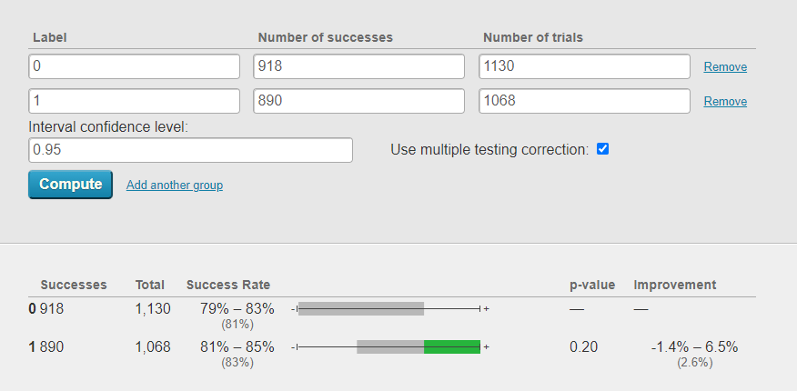

|  |  |  |  |  |
| --- | --- | --- | --- | --- |
| index | test_assignment | view_binary_30d | items | average_views_per_item |
| 0 | 0.0 | 918 | 1130 | 119.762832 |
| 1 | 1.0 | 890 | 1068 | 119.338951 |